Create

1. Development Progress Log

Week 1 (December 2024)

- The First Day, introduction to the project brief, idea generation, and brainstorming
After an initial search, I chose Housing as my investigation topic.
By using Google Advance Search, I found a publicly available dataset called “The Housing Agency”,
it became the starting point for my research.

Week 2 (January 2025)

- Christmas Break, no work took place.

Week 3 (January 2025)

- Investigation 1st draft, didn’t include a discussion of two alternative project ideas that were considered but rejected and a Identification of potential stakeholders and end-users.
- Investigation 2nd draft, missing parts were added however exceeded. However, I failed to adhere 400 words requirement.
- Investigation 3rd draft, words count under the limit and all essential parts included after adjustment.

Week 4 (January 2025)

- Plan and Design 1st draft
- I create the wireframe for my system with the tool “Whimsical.”
- I create the flowchart for my system with the tool “drawit.io”

Week 5 (January 2025)

- Plan and Design 2nd draft, fixed some typos and added wireframe and flowchart to the document.
- Plan and Design 3rd draft, add flowcharts for python data extracting sorting visualization.

Week 6 (February 2025)

- Create stage started, coding ………
- Data downloaded from different public datasets.
- Cleaned CSV files made, all information cleaned and sorted using Python.
- Frame of the website made, adjust background color and CSS.

Week 7 (February 2025)

- I was filling information into my interactive information system, adding SVG graphs, a Recommendation tool, and test the Firebase functionality. However, the installation of the Pygal module failed, so the graphs weren’t interactable at the beginning with several other problems encountered. I had been overly optimistic about my coding skills, so I decided to iterate back to the previous section of the create stage to make the code more concise.
- Start testing process, functional and unit testing.
- Unit test complete, test table created.
- Functional test complete, test table created. Final refine and optimize the overall visual layout of the webpage.

Week 8 (February 2025)

- Mid -Term Break, no work took place.

Week 9 (February 2025)

- Create 2nd draft, adjust contents to suit the marking scheme requirements. Evaluate in general rather than break into different parts.
- Write pseudocode for algorithms.
- Evaluation 1st Draft completed, exceeded 300 words limit.
- Review Evaluation 2nd Draft. Adding more comments on the source documentation for any modules or coding methods I used.
- add links and code comments regarding how to embed the SVG files.
- Create 3rd draft. The initial algorithm I chose wasn’t analytical, which is not what the marking scheme asked for. So I had to redo this section. I decided to use the decision algorithm from the rental budget recommendation tool on my website as the new algorithm to discuss.
- Evaluation 3rd draft. Redo the whole thing because I was evaluating myself and how I fulfilled the requirements ,instead of evaluating the artefact and how it meets the requirements, identifying the successes and areas for future improvement.

Week 10 (March 2025)

- Started to convert reports from Word documents to HTML webpage.
- Reorganize project folder in line with page 11 in the brief.
- Added comments about link to any modules/packages that I used with documentation that explains what am I doing.
- Add an error handling process to the recommendation tool of my interactive information system, that preventing users from entering 0 as their monthly rental budget.
- Enhance the recommendation tool so it can tell the user how far their budget is away from the average, rather than the previous version only provide a yes or no answer leave the user unclear about their affordability.
- Added Expected outcomes and Test ID Numbers to the test tables.
- IEEE Style Reference

Week 11 (March 2025)

- Make Word Count Table
- Record meeting the brief Video
- Final check and wrap up the project before the deadline.

Week 12 (March 2025)

- Project submitted to the state examination commission.

2. Problems Encountered

- Pygal is the visualization tool for my project, and it’s an external tool package that is not embedded in the Thonny IDE. Initially, I attempted to download it within the IDE, but I found it missing from the package library. To resolve this, I search online using resources like YouTube and Google, and found that I need to input the pip install Pygal command into the CMD console on my device, not directly into the Thonny shell.( https://www.pygal.org/en/stable/installing.html) This solution solved my issue and made my graphs interactable.
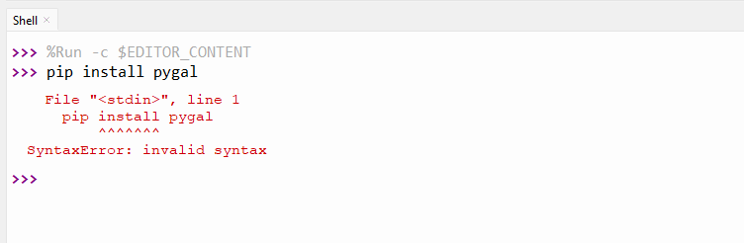

- When visualizing Housing Cost Overburden data into a bar chart, my initial idea was to use For Loops and Panda to extract Housing Cost Overburden data for six years from a large CSV file and visualize it to a single graph. However, the coding skills required were beyond my current abilities and understanding. Instead, I applied one of the computational thinking techniques --- Decomposition, which involves breaking problems down into smaller components so they can be tackled easier. In my project, the code became much more concise and easier to understand by dividing the large graph into six smaller graphs, each representing the data for a specific year. I was able to locate the relevant data for each year by using the row position and index in the CSV file, as the data was organized to repeat every four rows.
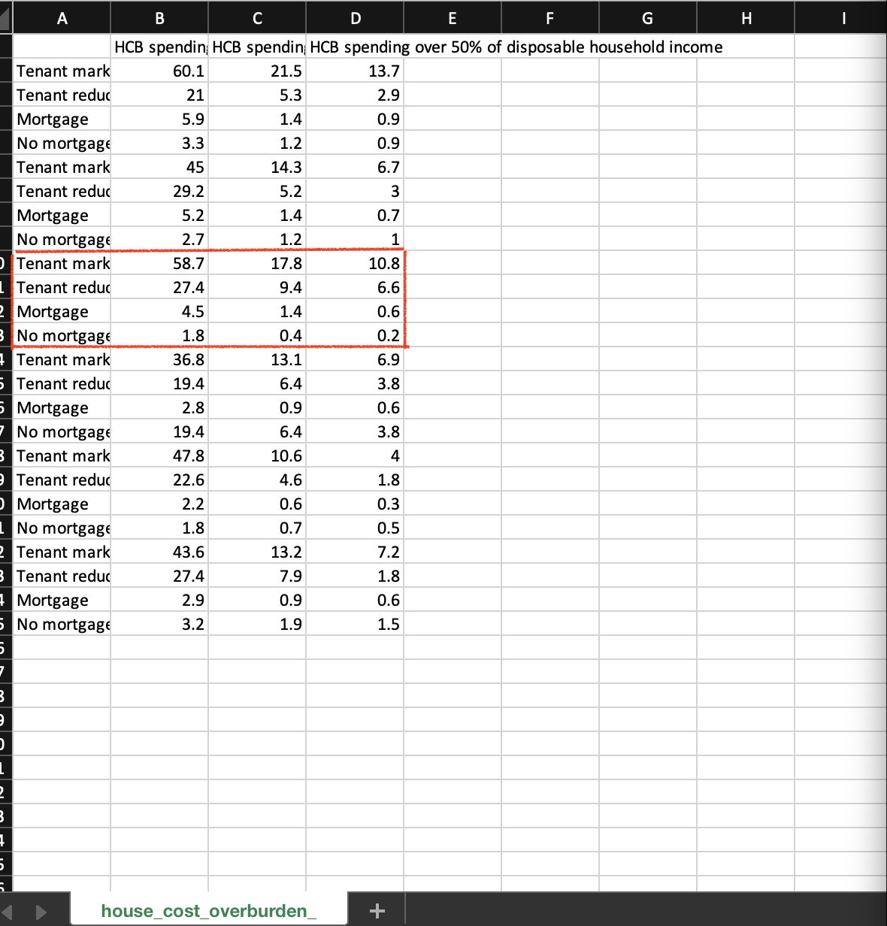
(Before) For example, HCB data for 2019 is stored together within a large csv file containing data from 2017 to 2022, it was difficult to visualize them together in a bar chart.

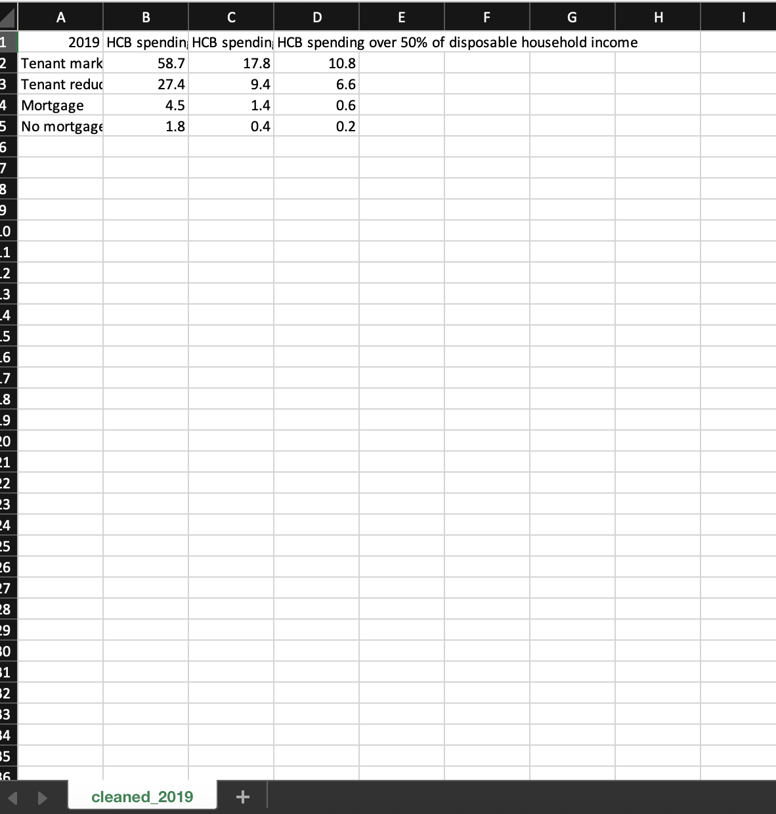
(After) HCB data for 2019 is isolated for further visualization to a bar chart containing data only for that year.

3. Program Testing

Unit Testing

Objective: helps to eliminate the risk of having bugs in code by break the software code to each unit, validate each unit and check whether they are performing as expected.

Webpage Display Test

- showHousePrices() function

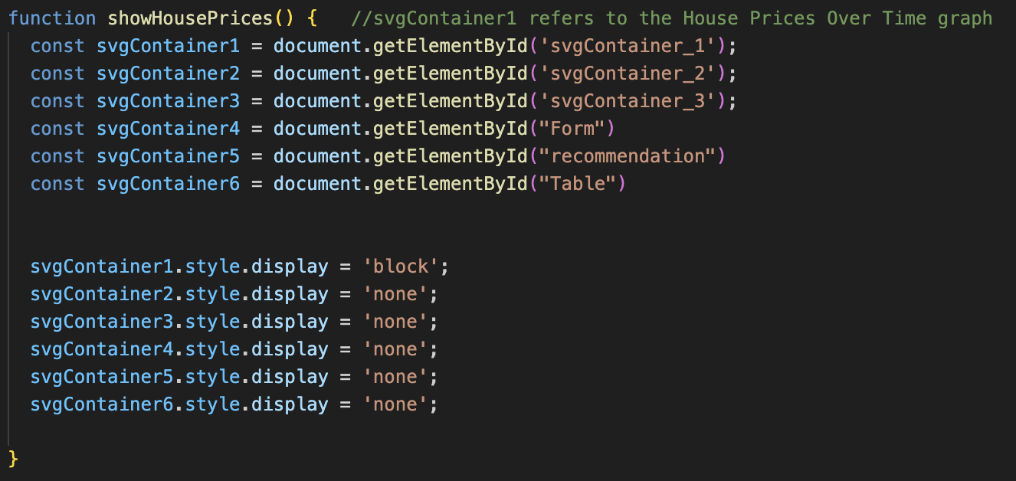

Verify that svgContainer_1 is displayed while others are hidden.

- showHCB() function

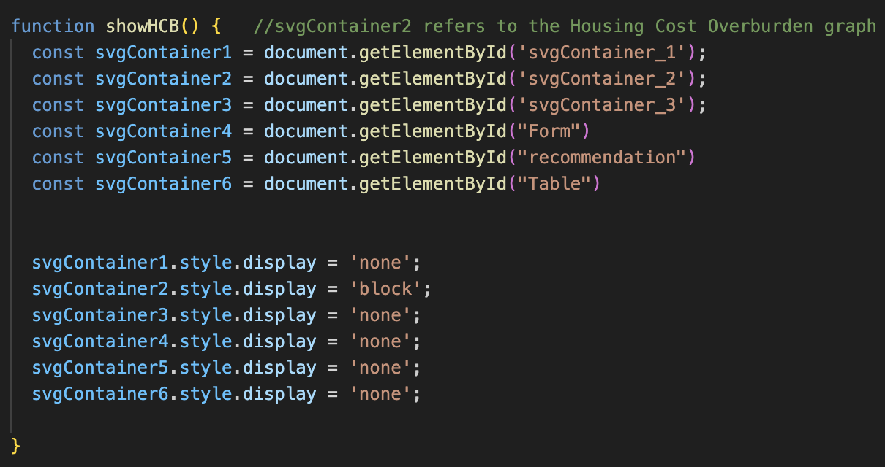

Verify that svgContainer_2 is displayed while others are hidden.

- showAverageRent() function.

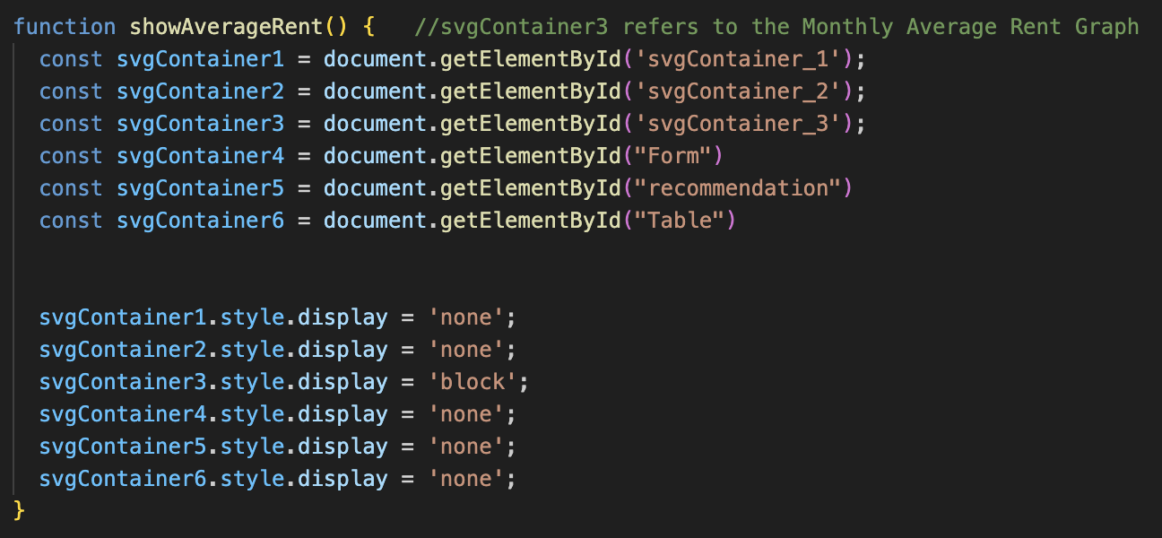

Verify that svgContainer_3 is displayed while others are hidden.

- showForm() function

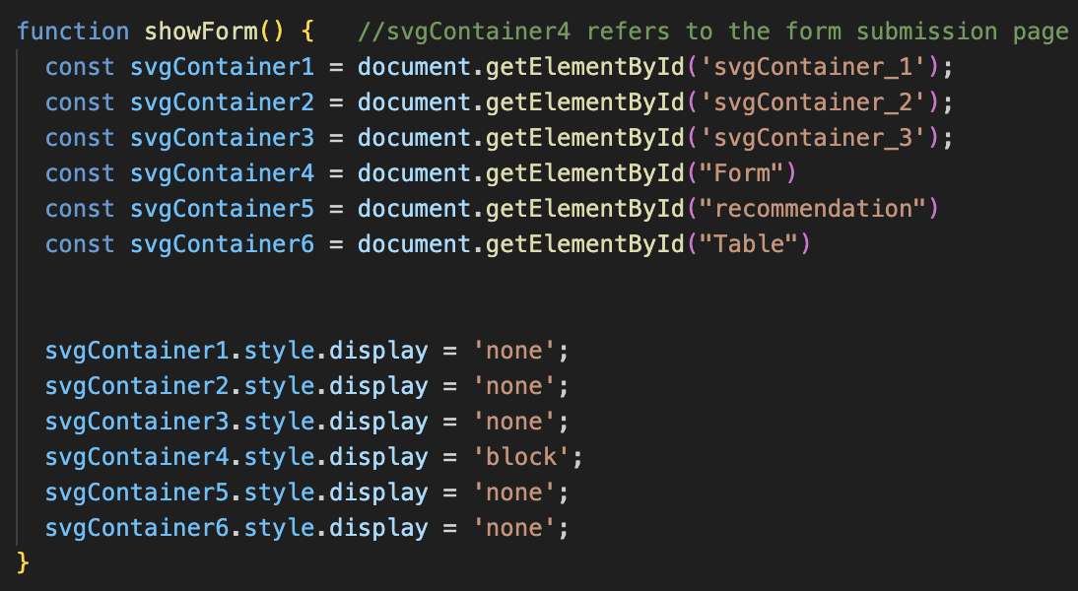

Verify that svgContainer_4 is displayed while others are hidden.

- showRec() (recommendation) function

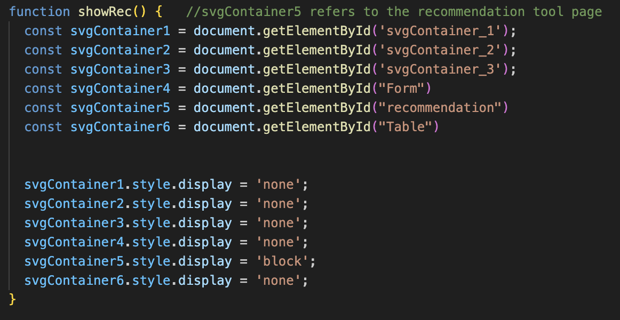

Verify that svgContainer_5 is displayed while others are hidden.

- showTable() function

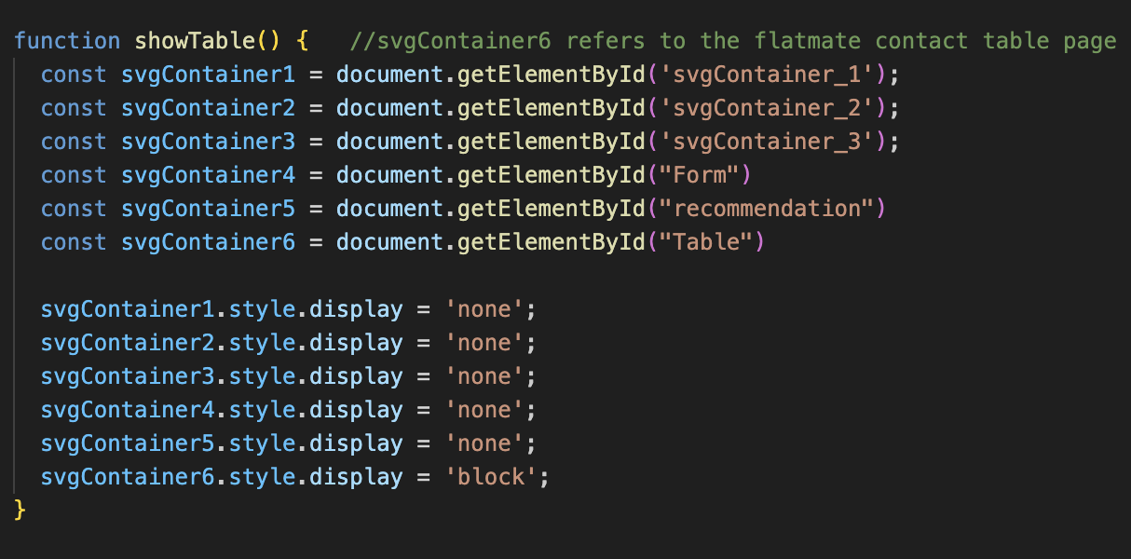

Verify that svgContainer_6 is displayed while others are hidden.

Test Table

ID | Test Cases | Expected Outcome | Actual Outcome | Pass/Fail
WD-1 | Call showHousePrices() function  (Button Clicked) | svgContainer_1 is displayed while other pages are hidden | svgContainer_1 is displayed while other pages are hidden | Pass ✅
WD-2 | Call showHCB() function  (Button Clicked) | svgContainer_2 is displayed while other pages are hidden | svgContainer_2 is displayed while other pages are hidden | Pass ✅
WD-3 | Call  showAverageRent() function  (Button Clicked) | svgContainer_3 is displayed while other pages are hidden | svgContainer_3 is displayed while other pages are hidden | Pass ✅
WD-4 | Call showForm() function  (Button Clicked) | svgContainer_4 is displayed while other pages are hidden | svgContainer_4 is displayed while other pages are hidden | Pass ✅
WD-5 | Call showRec() function  (Button Clicked) | svgContainer_5 is displayed while other pages are hidden | svgContainer_5 is displayed while other pages are hidden | Pass ✅
WD-6 | Call showTable() function  (Button Clicked) | svgContainer_6 is displayed while other pages are hidden | svgContainer_6 is displayed while other pages are hidden | Pass ✅

Functional Testing

Objective: validates the software system against functional requirements, test each of the individual functions or features of a completed system.

I invited my friends as tester during the level of functional testing.

Form Submission Test

Input Validation

- Test E-mail format validation (example@domain.com)

- Test that Budget only accepts numeric values.

- Test that Date of Birth only accepts Char values.
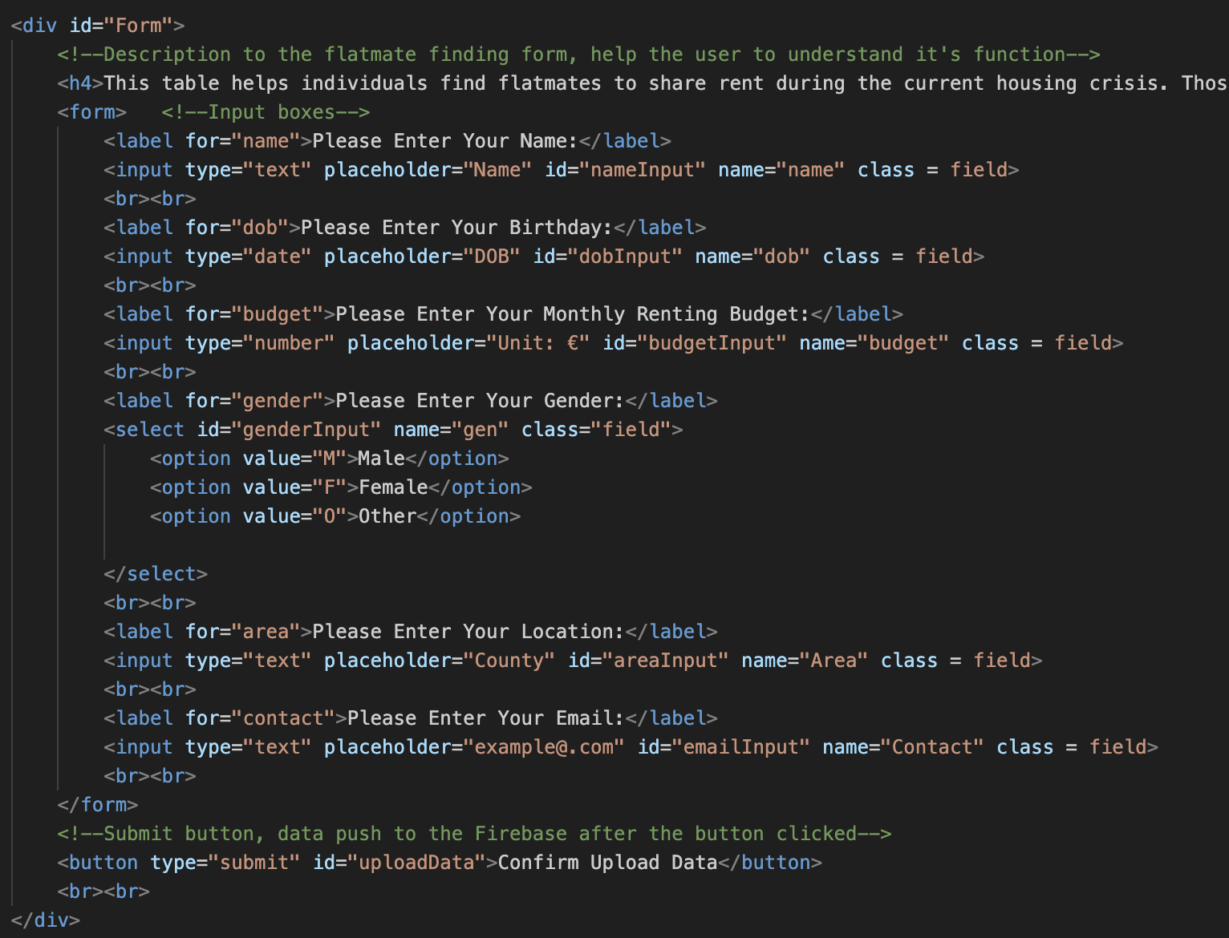
The validation process is completed by hardcoding the input box, so that only certain values can be accepted.

Test Table

ID | Test Cases | Expected Outcome | Actual Outcome | Pass/Fail
FS-1 | E-mail | Accept multiple value types, including str, int, float, etc. | Accept multiple value types, including str, int, float, etc. | Pass ✅
FS-2 | Birthday | Only Char value can be entered. | Only Char value can be entered. | Pass ✅
FS-3 | Budget | Only int value can be entered. | Float value is accepted. | Fail ❌
FS-4 | Gender | Only options in the selection box can be choose. | Only options in the selection box can be choose. | Pass ✅

Database Submission Test

- An alert box displays a confirmation message if the data is correctly pushed to the Firebase.

- If the alert box doesn't pop out during the uploading process, the user will be aware of the error.

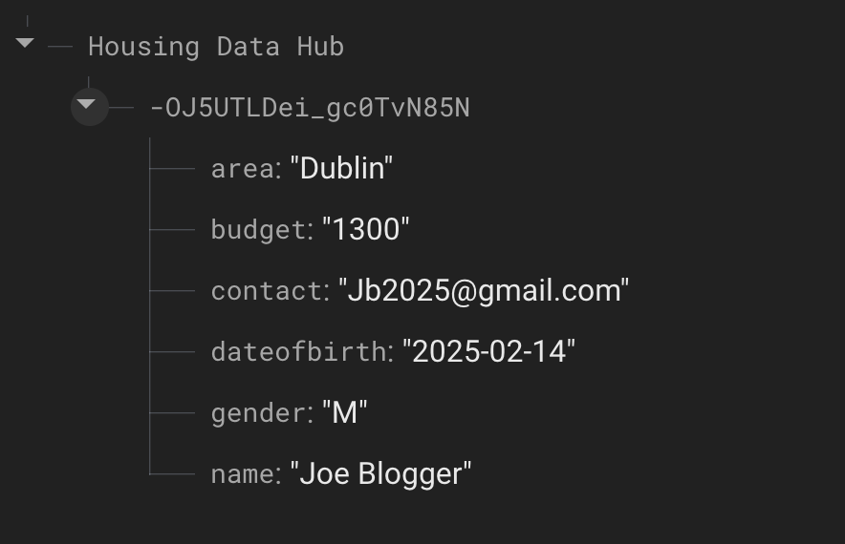

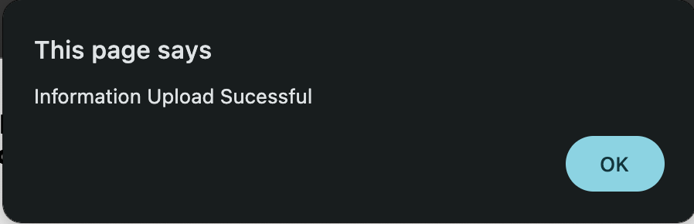

Test Table

ID | Test Cases | Expected Outcome | Actual Outcome | Pass/Fail
DS-1 | Submission  Successful | An alert box displays a confirmation message if the data is correctly pushed to Firebase | An alert box pops out to show the data is correctly pushed to Firebase | Pass ✅
DS-2 | Submission  Unsuccessful | No alert box displays a confirmation message | No alert box displays a confirmation message | Pass ✅

4. Algorithm

Budget Recommendation Tool

When the users use the budget recommendation tool on the housing data hub, they will be prompted to enter their desired rental location and budget. These two arguments are processed by the JavaScript algorithm outlined below.

Firstly, the algorithm determines the selected location. For example, the letter “D” refers to the Dublin Area. Next, the algorithm executes the relevant code section based on the user’s location. The user’s budget is compared to the average monthly rent obtained from my analytic data for that specific area. If the user’s budget is lower than the average rent, they will receive a message suggesting them to consider cheaper areas and how far their budget is away from the average to provide a better clarity about their affordability. Conversely, If the user’s budget is higher than the average rent, a message will inform that they should be able to afford the rent.

Supplementary recommendation:

If the user's budget is close to or able to afford the rent in the area (budget difference <= 30% of the average rent ), prompt them to learn negotiation skills with landlords.

If the user's budget has a large gap compared to the average rent in the area,
area (budget difference > 30% of the average rent ), prompt them to get assistance from government subsidy projects or low-rent housing policies.

Additionally, the algorithm includes an error-handling process that triggers an error message in the event of invalid inputs.

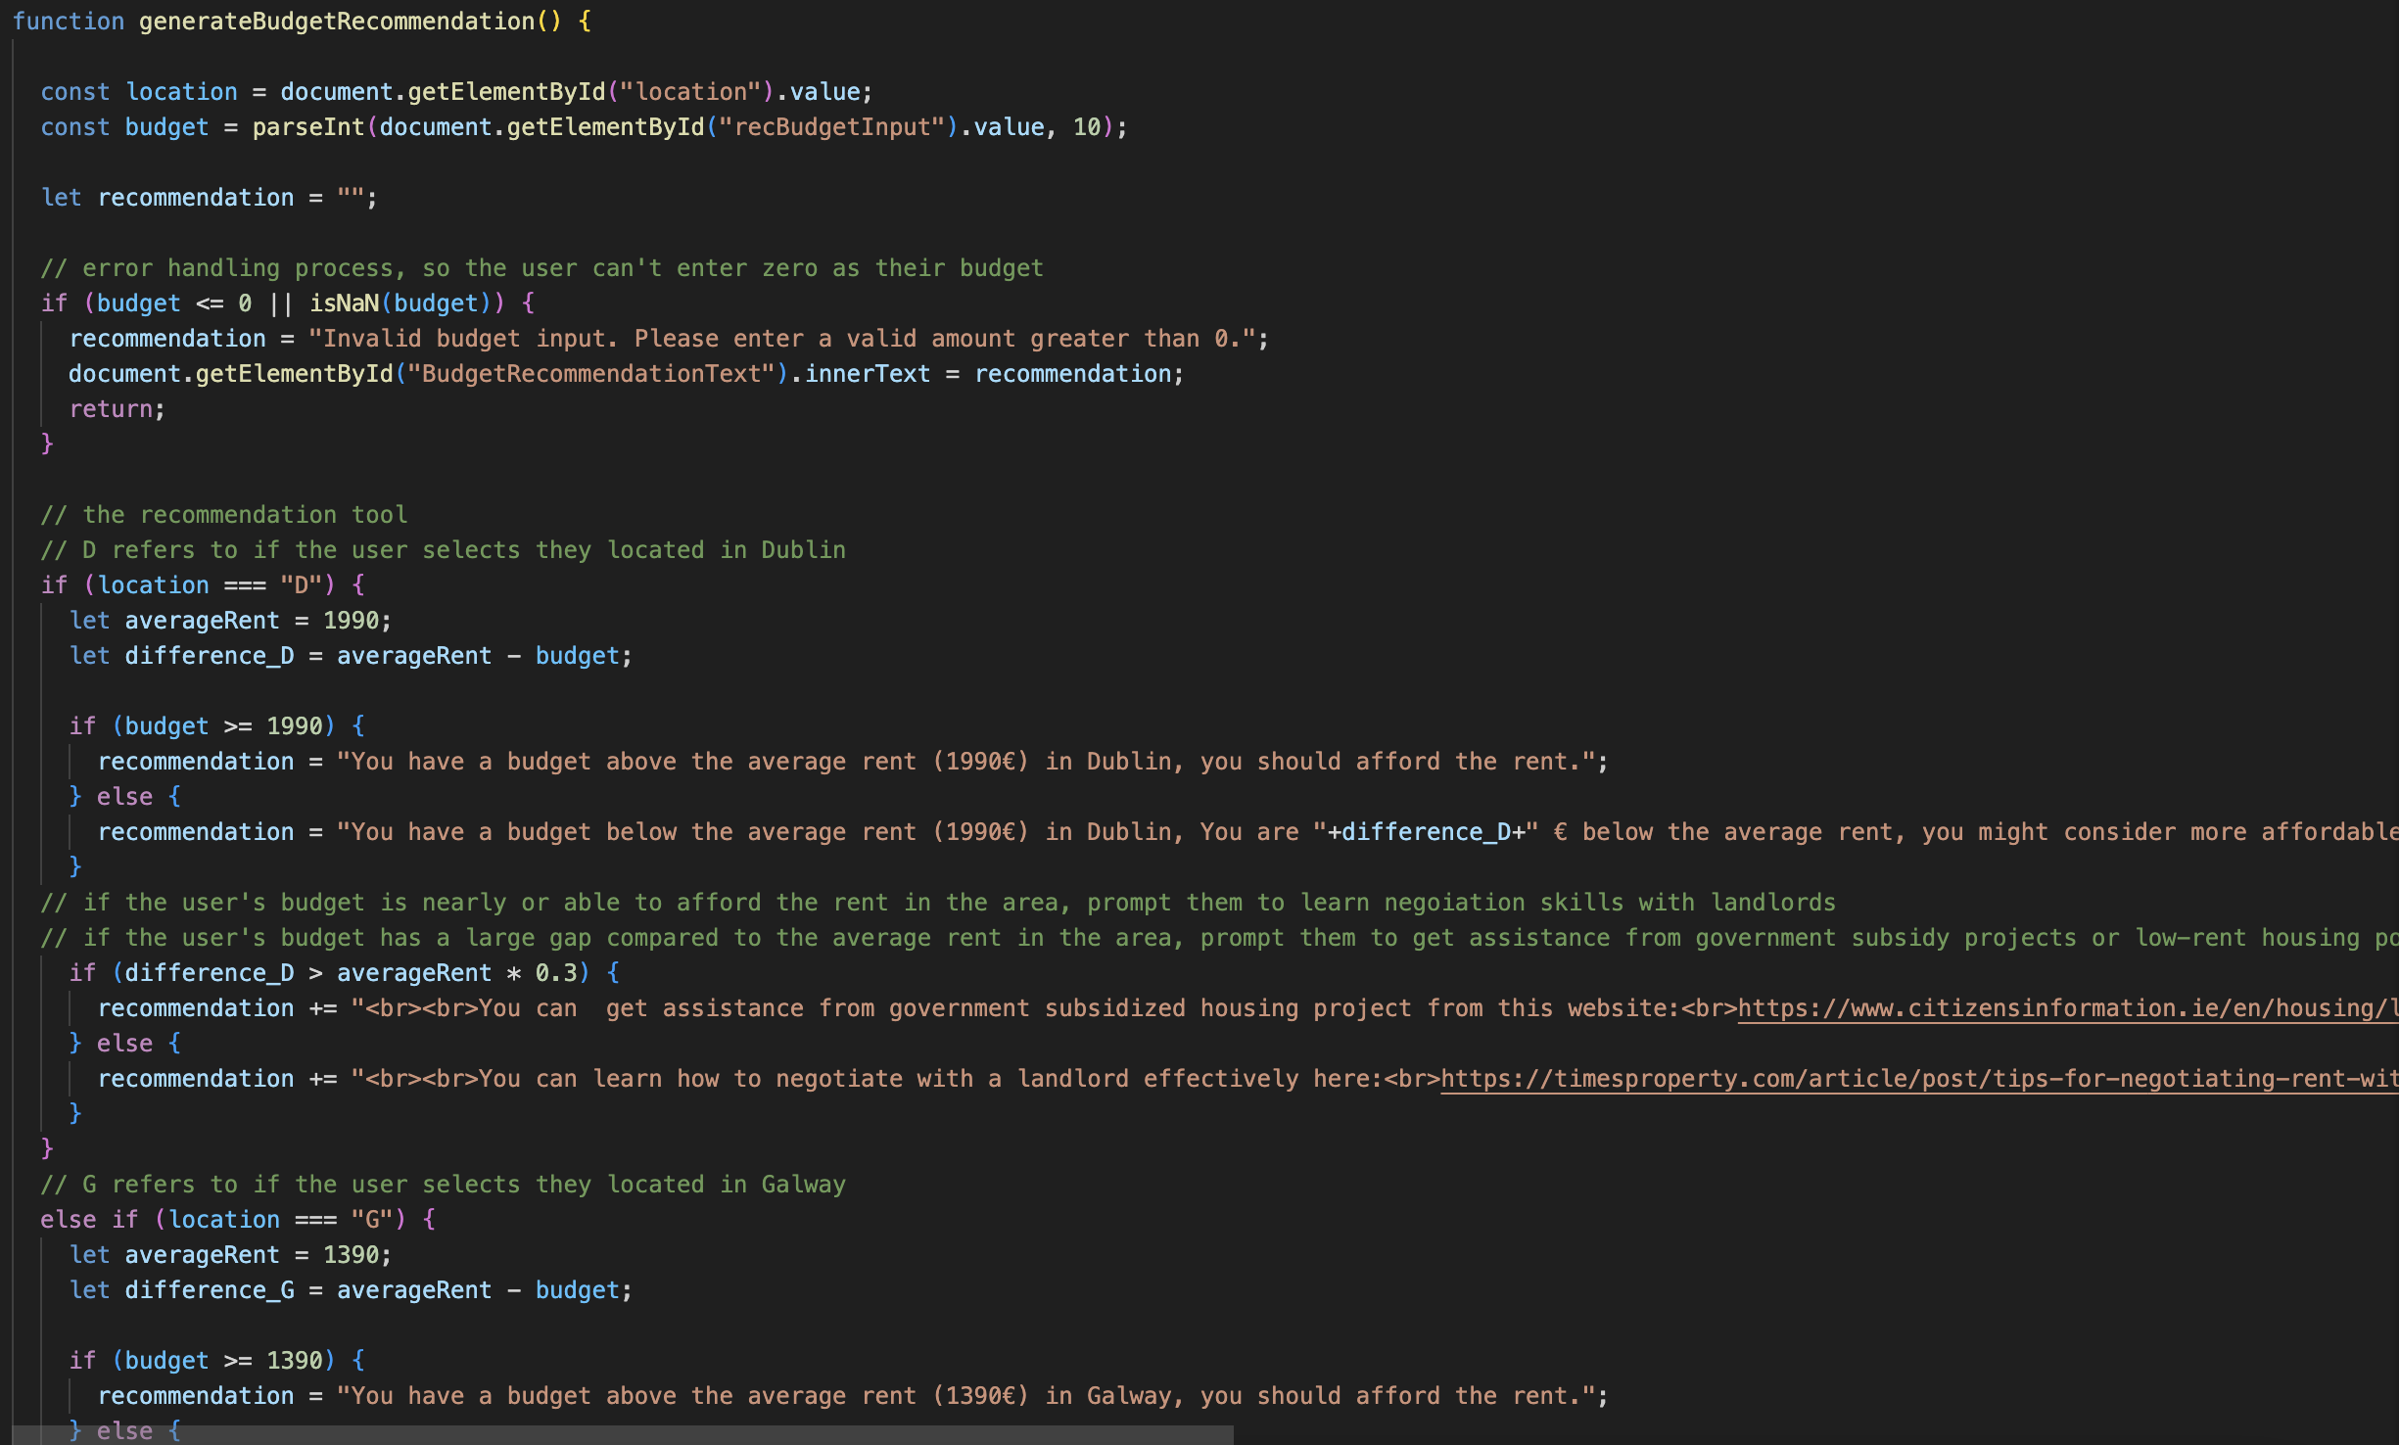
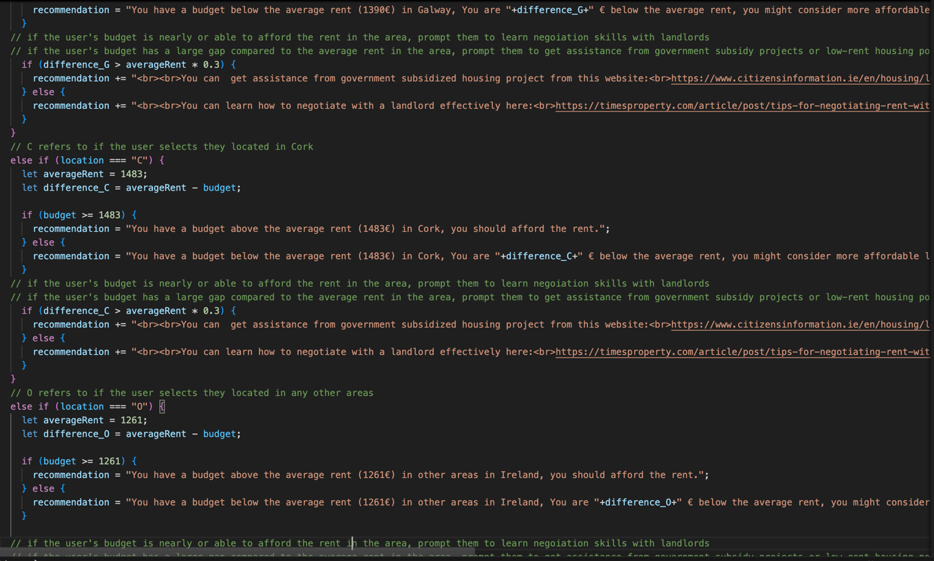
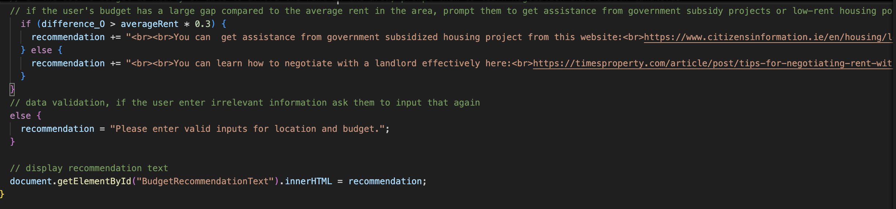

Pseudocode

